Automated Folder and Drawing Creation

Stresscrete

Document Approval
Approver | Approved Date | Rejected Date | Comments
Don Forbes

Part 1 Functionality Overview
Objectives
Stresscrete would like Orderstream to automatically create a folder on their S drive within an existing folder and then copy all of the drawings associated with that Item# and child components to the folder. They would also like a PDF of the existing BOM at the time of the order release. Examples below show the existing folder creation, and what is required.
Existing Workflow: Currently Stresscrete manually copies these items to the existing folder on their S drive, but would like to make this an automated process.
Proposed Solution: When the workflow for the order has step 1 completed – Task 1 - released to production, it would trigger the creation of the folder and copy all of the related drawings from the parent and child components to it.
Please see below mock-up of the proposed solution:
User has completed Task No 1 within the Sales Order Workflow and saved the order
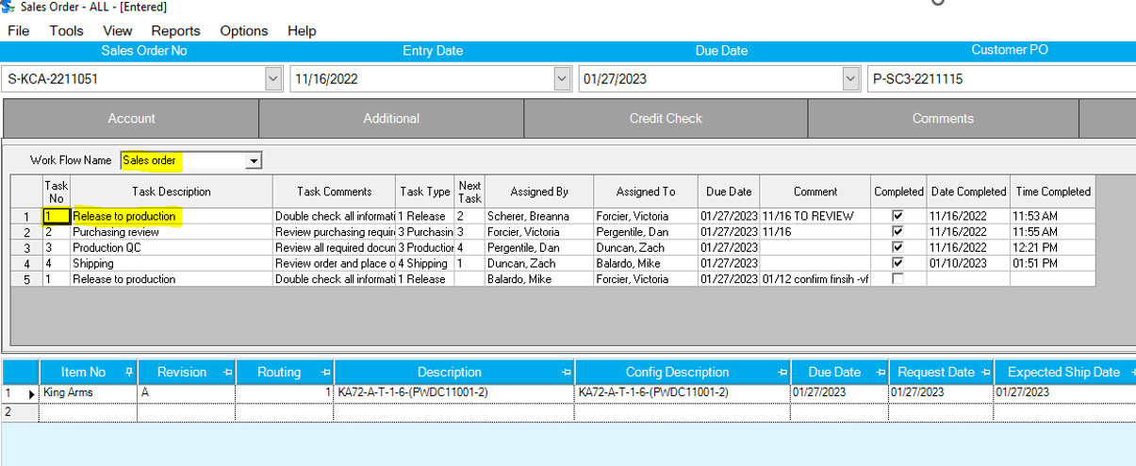
Automatic Parent Line Folder created on the S drive at the following file path(located in document storage if we need reference to the file path)
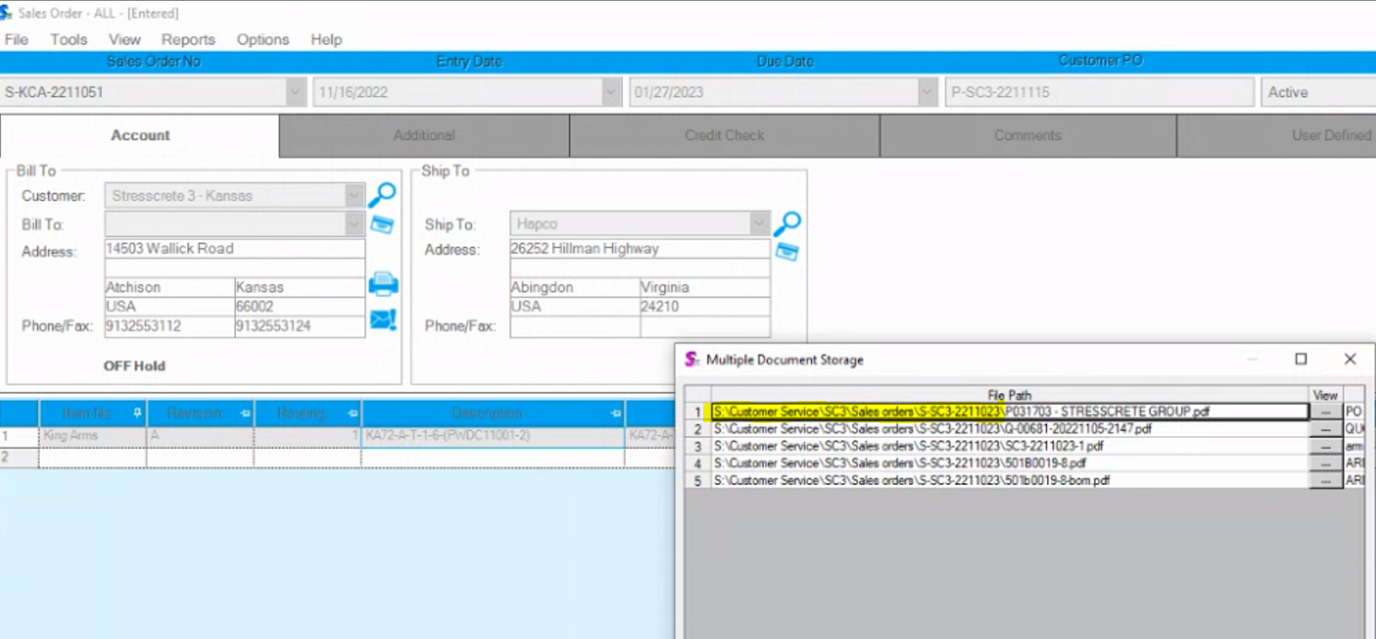
S:\Customer Service\SC3\Sales orders\S-SC3-2211023
King Arms -line 1
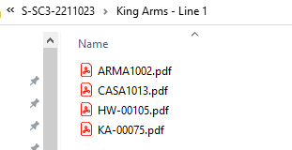
The folder would contain any drawings available in the Item Master within document storage against the Parent Item or Child components
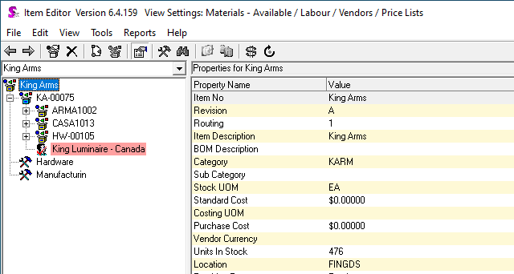
The drawings would be labeled to match the BOM - ie KA-0075, ARMA-0075, CASA1013, and HW-00105
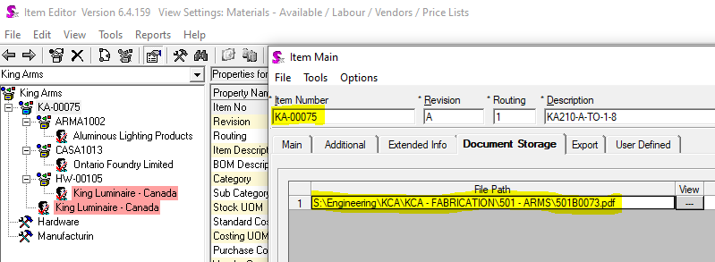
If we can also create a PDF of the existing BOM so they can see what the BOM components are at the time of release to production.

They would like the following to occur(if possible):
- If the Sales Order Line is changed to a different item number, after the WO has been created: the old item number folder and drawings would be replaced by the new item number folder and drawings.
- If the Sales Order Line is deleted, the subsequent folder and drawings would be deleted.
- If the Sales Order is deleted – no change required – leave the folder and subfolder.
- If the drawings are updated while the sales order is still in process – original drawings should remain. If the drawings drawings need to be updated, their process is to update the item code, which would then trigger #1 above.
User Roles and Responsibilities
In order for the action of the folder creation to be triggered, the user would need to complete Task 1/Step 1 as described above.
Interactions with Other Systems
N/A
Production Rollout Considerations
N/A
Terminology
N/A

Date | Enhancement | Requested By | Notes | Priority | Release Status

